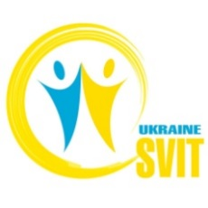
“Change for Media - Presenting the future - Youth Exchange”
17-26 August, 2018, Hungary

Application Form
First Name
Last Name
Male\Female
International Passport Number.
Biometric or no?
Date of Birth
Place of Study (Work)
Home address
E-mail
Telephone
Facebook account
Why do you want to take part in the project? (2-3 sentences)
How well do you understand and speak English?
Have you ever been a volunteer or took part in international projects? If yes – describe your experiences

Анкети і будь-які питання надcилати за адресою: projects@svit-ukraine.org
Дедлайн подання заявок – 10 липня (група може бути сформована раніше, отже поспішайте, друзі :-)

